LockdIn System Design Report

SED 700 Capstone 1
Professor Miguel Watler

Crissha Salaritan, Jasleen Kaur, Kasra Bina, Ma Toan Bach
November 30, 2025

Table of Contents
Table of Contents 2
1. Introduction & Assumptions 3
Problem and System Goal 3
Actors and Users 3
High-Level Requirements 4
2. Architecture 6
Architectural Style: Client-Server Architecture 6
System Context: 6
Component Overview 8
How the Components Interact 10
3. High Level Design 14
Runtime Environment and Assumptions 14
System Assumptions 14
Hardware and OS Integration 14
Security Model 15
User Interface 17
Internal Interfaces (Microservice APIs and Communication) 19
Internal Interfaces Communication 22
External Interfaces and Communication 23
Requirements Mapping 26
Diagrams 29
4. UML Diagrams 32
5. Alternate Designs 38
6. Low Level Design 41
Module 1: Usage Aggregator Service (Usage Tracking & Analytics Engine) 41
Module 2: Rule Evaluator & Lock Enforcer 43
Module 3: Notification & Accountability Dispatcher 46
Module 4: Authentication & User Management 49
Database Design & Schema Overview 52
7. Conclusion 55

1. Introduction & Assumptions

Problem and System Goal
The LockdIn mobile application is designed to help users reduce unhealthy screen time by enforcing strict, non-bypassable app lockdowns once time limits are reached . In essence, LockdIn provides users with a reliable, non-ignorable way to control their screen time through automated usage monitoring, customizable limits, and accountability features. By combining behavioral tracking, engaging notifications (from friendly nudges to humorous or edgy motivation), and partner accountability, the system aims to improve user focus, productivity, and digital well-being.

Actors and Users
- The primary end-users are students and young professionals (or more generally, individuals) who are motivated to curb their screen time habits . These users interact with a mobile app on their device.
- A secondary actor is the accountability partner (friend, parent, or mentor) designated by the user. This contact receives notifications or summary reports when the user exceeds limits .
- On the system side, the LockdIn backend (cloud services) acts as an automated actor processing data and enforcing rules.
- Additionally, platform providers (the mobile OS APIs on Android/iOS) are external systems that the app leverages for usage statistics and lockdown enforcement (e.g. Android’s Device Admin API, Apple’s Screen Time API).
- For completeness, administrators/DevOps personnel exist as actors with limited roles (deploying and maintaining the system infrastructure) , though no end-user-facing admin interface is in scope.

High-Level Requirements
The main capabilities of LockdIn are derived from the High-Level Requirements (HLRs) defined in the project documentation. Refer to the SRS for detailed requirements, but in summary, the system must:
- Monitor Device Usage: Track daily and weekly app usage, and provide analytics on totals and trends (HLR-1) . Users should see a dashboard of screen time and usage breakdowns.
- Enforce Lockdown Rules: Let users define customizable screen-time limit rules for apps or categories, and lock those apps when limits are reached (non-bypassable on Android) (HLR-2) . On iOS, enforce “soft” limits via reminders due to platform restrictions.
- Provide Behavioral Insights: Offer insights into usage patterns – e.g. identifying peak usage times, app category breakdowns, or location-based triggers for excessive use (HLR-3) .
- Custom Notifications: Support multiple notification tone profiles (e.g. fun, edgy, professional) that users can select for reminders, to improve engagement (HLR-4) .
- Accountability Features: Allow users to nominate a trusted contact to receive notifications when limits are exceeded, promoting accountability (HLR-5) .
- Fast Onboarding: Include a quick onboarding flow (target under 2 minutes) to get first-time users set up with permissions and a default rule (HLR-6) .
- Accessibility & Privacy: Ensure the app is accessible (conforming to WCAG 2.1 AA for usability by people with disabilities) (HLR-7) . Provide privacy controls like “local-only” mode and data export/delete options (from additional requirements) .
- Behavior Change Efficacy: The product should demonstrably help reduce users’ screen time (target ≥25% reduction in average daily screen time after 4 weeks of use – HLR-8) .
- User Retention: The solution should be engaging and effective enough that at least 70% of pilot users continue using it actively (HLR-9) .
Key Assumptions:
- Development is initially focused on Android, since Android’s OS permissions allow deeper usage monitoring and true app blocking.
- It is assumed that on iOS, strict lockdown is not possible without jailbreaking, so the app will use Apple’s approved APIs to impose soft limits and reminders only .
- Users will grant the necessary permissions (usage stats access, notification access, device admin on Android, etc.) during onboarding .
- Users consent to share basic usage data with the system and with their chosen accountability partner – privacy options will be provided, but core functionality relies on data collection.
- All required development tools, SDKs, and test devices are available to the team, and that the backend infrastructure can be deployed in a cloud environment (e.g. AWS) within project resources .

2. Architecture

Architectural Style: Client-Server Architecture
A native mobile client (the LockdIn app on Android/iOS) communicates over the internet with a cloud-based backend.
The backend is organized as a set of microservices deployed on a scalable cloud platform (Kubernetes on AWS) .
Communication between the mobile app and the backend uses RESTful HTTPS APIs for simplicity (JSON over TLS).
Within the backend, services communicate with each other via high-performance gRPC calls using protocol buffers .
The architecture also includes external integrations where the backend uses a managed PostgreSQL database for persistence , and leverages external messaging services (like Firebase Cloud Messaging, email/SMS APIs) for pushing notifications to devices or contacts.
This microservice approach (as opposed to a monolithic server) was chosen for scalability and clear separation of concerns: different services handle usage data, rule evaluation, notifications, etc., and can be scaled or modified independently.

System Context:
At a high level, the LockdIn system interacts with several external entities: the end user (via the mobile app UI), the accountability contact (who receives emails/SMS reports), the mobile OS platforms (Android/iOS APIs that enable usage tracking and app blocking), and external notification services (for delivering push notifications or emails). Figure 1 illustrates the system context, showing LockdIn (encompassing the app and backend) at the center and its key external actors and systems around it:
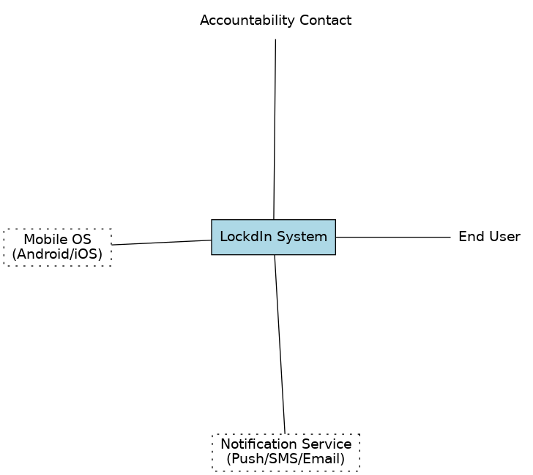
Figure 1: System context diagram of LockdIn, showing the mobile app and cloud system in the center, the end user and accountability contact as external actors, and the platform/notification services it interacts with.
In the context diagram, the End User interacts with the LockdIn System through the mobile app’s UI (e.g. setting rules, viewing stats).
The Accountability Contact is external but receives output from the system (notifications/reports when the user exceeds limits).
The LockdIn system also interfaces with mobile OS APIs (to gather usage data and enforce locks via Android Device Administration or iOS Screen Time frameworks) and with notification services (e.g. push notification infrastructure, email/SMS gateways) to deliver messages out to users and contacts.

Component Overview
Internally, the LockdIn backend is composed of several cooperating microservice components, each with a distinct responsibility. Figure 2 provides a component and deployment view of the system’s core elements and their interactions:

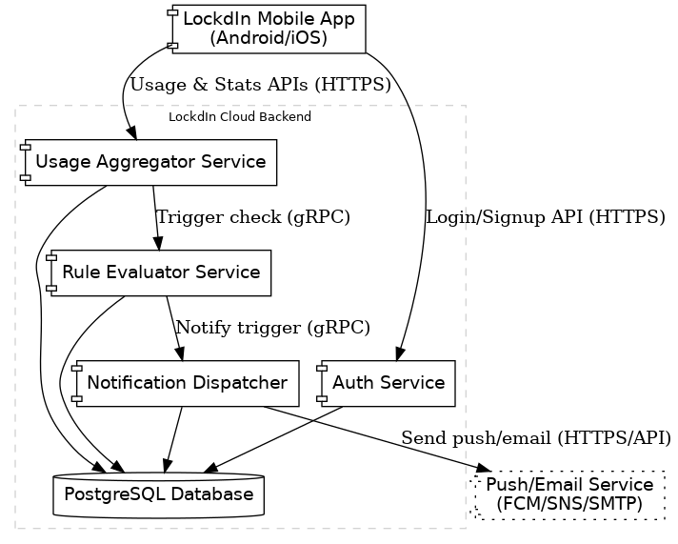
Figure 2: High-level component architecture. The LockdIn Mobile App communicates via HTTPS APIs to cloud services (Auth, Usage Aggregator). Internal backend services (Usage Aggregator, Rule Evaluator, Notification Dispatcher) communicate via gRPC and share a Postgres database. External services (FCM/APNs, email/SMS gateways) are used by the Notification Dispatcher to deliver messages to devices or contacts.
As shown in Fig. 2, the LockdIn Mobile App (Android or iOS) is the client component that handles the user interface and local monitoring. It communicates with the cloud through a REST API (HTTPS). Key backend components include:
- Auth Service: Manages user accounts, authentication and authorization (fulfilling FR-1). It allows users to register, log in (including OAuth options), and manages secure session tokens. It interacts with the database to store user credentials (hashed passwords) and profiles .
- Usage Aggregator Service: Ingests app usage events from the mobile app and updates usage statistics and analytics (fulfilling HLR-1 and parts of HLR-3). When the app sends periodic usage data (e.g. “Facebook used 10 minutes”), this service validates and records the event in the PostgreSQL database, updating aggregated totals (daily and weekly per app/category) . It also provides an API endpoint to fetch analytics (e.g. GET /api/v1/analytics) returning summarized usage stats for the dashboard .
- Rule Evaluator Service: Applies the user-defined rules to the aggregated usage and determines if any limit has been exceeded (fulfilling HLR-2). It fetches the relevant rules from the database and compares current usage against the limits . If a limit is reached, the Rule Evaluator formulates an action – e.g., a command to lock a specific app (on Android) or a notification that time is up (on iOS) . This service encapsulates the core logic for enforcing screen-time rules.
- Notification Dispatcher Service: Handles all user and external notifications, including on-device alerts and accountability messages (fulfilling HLR-4 and HLR-5). When triggered (either by the Rule Evaluator for an immediate limit breach, or by scheduled summary jobs), it composes the notification content based on the user’s chosen tone profile and the context . It then delivers the notification: for the user, typically via a push notification to the mobile app; for an accountability contact, via email or SMS. This service connects to external providers (e.g. Firebase Cloud Messaging for push, or an email/SMS API) to send out the messages . It also logs notification deliveries in the database for audit/history.

How the Components Interact
All these backend services share a common database (PostgreSQL) for persistence of user data, rules, and usage records . They communicate over a private network (within a Kubernetes cluster). An API Gateway or NGINX ingress routes external API calls from the app to the appropriate internal service – for example, usage events are routed to the Usage service, login requests to Auth. Internal calls (Usage service triggering the Rule Evaluator, Rule Evaluator calling the Notification service) use gRPC for efficiency . The mobile app itself also directly interfaces with OS-level services: on Android it uses the Usage Stats and Device Admin API to monitor apps and enforce locks on the device , while on iOS it uses Apple’s Screen Time/DeviceActivity APIs to monitor usage and display system-managed reminders . These platform interactions are encapsulated in the mobile client – the backend simply informs the app what action to take (lock or warn), and the app carries it out using the OS capabilities.

Non-Functional Considerations
The architecture is designed for performance and scalability. The use of local processing on device (batching usage events) and lightweight JSON APIs ensures that normal usage reporting has minimal latency and battery impact. The backend microservices can be scaled horizontally (e.g. multiple instances of the Usage service behind a load balancer) to handle increasing numbers of users or events. Because certain operations (like evaluating rules or sending notifications) are triggered by events, the system can naturally scale by processing these in parallel on separate service instances. For reliability, data is stored in a robust ACID-compliant DB (PostgreSQL on AWS RDS) with backups, and the services run in a clustered environment (able to recover from node failures). The design includes retry mechanisms and graceful fallbacks – e.g. if the network is down, the mobile app queues usage events for later ; if the database is unreachable momentarily, the Rule Evaluator can respond with an “error, try later” action so the client can enforce a local fallback if possible .

Security & Privacy
All communication is encrypted (HTTPS for app-to-backend, and internal gRPC channels secured via mTLS) . User data in the database is encrypted at rest via cloud KMS . The system follows a “privacy by design” approach: it collects only the data needed to implement the features (mainly app IDs, usage durations, timestamps) and nothing overly personal . Users can opt for a local-only mode (HLR-9 related feature) in which raw usage logs are kept only on device and only aggregated summaries are sent to the backend . All data retention is configurable and old raw data gets purged or anonymized via background jobs (per data retention policies) . The app explicitly explains what permissions are needed and why, during onboarding, to ensure transparency .

Traceability Matrix
The table below maps the major High-Level Requirements to the system components that realize them:
HLR (Requirement) | Relevant Components
HLR-1. Monitor daily/weekly usage & show trends | Mobile App (collects usage data, displays dashboard), Usage Aggregator (tracks events, computes totals), Analytics DB (stores usage)
HLR-2. Customizable lockdown rules | Rule Evaluator (stores & evaluates rules), Mobile App (enforces lock via OS, UI for rule setup)
HLR-3. Behavioral insights (patterns) | Usage Aggregator (computes trends like peak hours, location patterns), Mobile App (UI to present insights)
HLR-4. Multiple notification tone profiles | Notification Dispatcher (formats message according to tone), Mobile App (user selects profile in settings)
HLR-5. Accountability notifications | Notification Dispatcher (triggers email/SMS to contact), Backend DB (stores contact info), External Email/SMS service
HLR-6. Quick onboarding ≤2 minutes | Mobile App (streamlined onboarding flow UI), Auth Service (fast account setup), OS integration (quick permission prompts)
HLR-7. Accessibility (WCAG 2.1 AA) | Mobile App UI (high-contrast theme, larger fonts, content descriptions), Notification content (accessible wording)
HLR-8. Reduce screen time ≥25% | Rule Evaluator + Mobile App (hard lockdowns directly reduce usage), Notification/Insights (behavior change nudges). All core features together contribute to this outcome.
HLR-9. ≥70% users remain active | Engaging UX (Mobile App’s user-friendly design, HLR-7), Motivational notifications (HLR-4) – overall system quality and usefulness drive retention.
(Table notes: This traceability focuses on primary feature components. Many requirements involve multiple parts of the system in tandem. For example, HLR-2 involves the backend Rule service and the on-device enforcement working together. HLR-8 and HLR-9 are business-level goals achieved by the collective effect of the components listed.)

3. High Level Design

Runtime Environment and Assumptions
LockdIn is delivered as native mobile apps on Android and iOS communicating with a cloud backend. The backend runs as a set of containerized microservices on a Kubernetes cluster (deployed on AWS) . A PostgreSQL database is used for persistent storage (e.g. usage logs, rules, user info) . The system integrates with external messaging services: Firebase Cloud Messaging (FCM) for Android push notifications, Apple Push Notification service (APNs) for iOS, and third-party email/SMS APIs (e.g. AWS SES for email, Twilio for SMS) to notify accountability partners .

System Assumptions
We assume users grant all required OS permissions during onboarding (Android Usage Stats and Device Admin, iOS Screen Time and notification access) . The initial deployment is a small pilot, so the system is scaled for a modest number of users, but the cloud architecture can scale out as needed. Reasonable network latency is assumed for device-backend communication; the app batches data to tolerate brief offline periods. Android is the primary platform at first (due to its deeper monitoring and true app blocking capabilities), while on iOS the app uses “soft” enforcement given platform limitations . We assume the backend cluster is reachable with minimal downtime, and that the cloud environment (AWS) and development tools are available to the team .

Hardware and OS Integration
LockdIn leverages native OS capabilities for usage tracking and app blocking. On Android, the app uses the UsageStats API to continuously monitor foreground app usage and durations. To enforce locks, LockdIn enrolls as a Device Administrator app, allowing it to block launches of target apps when limits are exceeded . This means that once an Android user hits a limit, LockdIn can immediately display a full-screen “app locked” overlay or otherwise prevent the restricted app from opening . On iOS, third-party apps cannot truly lock other apps (no equivalent device-admin capability), so LockdIn integrates with Apple’s Screen Time or Device Activity APIs to read usage statistics and schedule reminders. When an iOS limit is reached, the app triggers a Screen Time reminder notification – a pop-up alert informing the user they’ve hit their limit . This “soft” limit relies on the user’s compliance (due to iOS sandbox restrictions) and cannot force-close the app, but it still serves as a strong deterrent.
To minimize battery and performance impact on devices, the design offloads heavy computation to the backend. The mobile app performs only lightweight tasks (usage logging, UI updates) and batches its data transmissions. For example, usage events are aggregated on-device and sent to the server periodically (every few minutes) rather than in real time, reducing network chatter and conserving battery . The backend performs resource-intensive work like computing analytics (trends, insights) and evaluating complex rule logic, taking advantage of cloud processing power instead of draining the phone’s CPU . This division also improves enforcement security: rules are checked on a server the user cannot tamper with easily . Overall, the app respects mobile constraints by doing just the necessary device-side polling (which is scheduled in the background as permitted by the OS) and relying on push notifications from the server to react in real time, rather than keeping long-running background services active.

Security Model
Security and privacy are core to LockdIn’s design. All client-server communication uses HTTPS with TLS encryption . Within the backend, microservice-to-microservice calls use authenticated channels (e.g. gRPC with mutual TLS) so that even internal traffic is encrypted . The database encrypts data at rest (using cloud Key Management Service for keys) . User authentication is handled via JWT tokens: when a user logs in or registers, the Auth service issues a signed JWT that the client presents on subsequent requests. Tokens are short-lived and securely verified on each request (either by a centralized Auth service or via shared public keys) to prevent spoofing. Passwords (for users who create accounts) are never stored in plaintext – only securely hashed values (e.g. bcrypt) are kept in the database . For additional safety, the Auth module applies measures like rate limiting or exponential backoff on login attempts to mitigate brute force attacks .
The system follows a “privacy by design” approach , collecting only the minimum data needed to function – primarily app IDs, usage durations, timestamps, and basic account info. Personal Identifiable Information (PII) is kept to a minimum (the system does not collect sensitive content or detailed user data beyond what’s required for the features). Users can even opt for an anonymous (device-only) mode with no email or name provided; in this mode, data is stored only locally on the device or in an anonymized way on the server . Anonymized or local-only users still get full functionality except cloud backup of data. All data retention is governed by user control and regulations – users can request deletion of their data, upon which the backend will erase their usage records, rules, and contact info (all user-linked records cascade-delete) . This fulfills GDPR-style requirements for the “right to be forgotten.” Routine purging is in place for stale data: raw usage logs older than a retention period are aggregated or anonymized and then deleted to protect privacy .
Threat Model
The system assumes the mobile clients are honest and not compromised; a determined user with a rooted/jailbroken device might bypass controls, but such scenarios are out of scope beyond deterrence measures. All API calls include the user’s token, which is validated to ensure no unauthorized access – e.g. one user cannot retrieve another’s data. We mitigate token spoofing by using signed JWTs (non-forgeable without the server’s secret) and by transmitting them only over TLS. The backend and database are deployed in a secure VPC with firewall rules; each microservice and database account uses least-privilege access (only the permissions it needs) . Data shared with accountability partners is limited to summary notifications (e.g. a simple “limit exceeded” alert) to reduce privacy impact if those messages were exposed . In summary, the design uses standard security best practices (encryption in transit and at rest, hashed credentials, minimal data storage, and rigorous auth) to protect user data and ensure only authorized actions occur.

User Interface
The LockdIn UI is mobile-first, designed for clarity and engagement on small screens. Upon first launch, users go through an onboarding wizard that introduces the app’s purpose and requests the necessary permissions . The onboarding flow is streamlined (targeting under 2 minutes to complete, per HLR-6) – it guides the user to enable usage access and admin privileges on Android, or Screen Time and notification permissions on iOS, with friendly explanations of why each is needed. Account creation is optional; the user may sign up with email/password or continue in device-only mode for privacy . Either way, the final onboarding step suggests a default rule (e.g. a daily total screen time cap) to help new users get started quickly .
Once onboarded, the user lands on a Dashboard screen that summarizes their device usage. This dashboard shows daily total screen time, a breakdown by app or category, and weekly trends (e.g. graphs of usage over days) – fulfilling the analytics insights requirement (HLR-1 and HLR-3) . The UI employs charts and infographics to make these patterns easily understandable. A menu or tab interface lets the user navigate between main sections: Usage Stats, Rules, and Settings/Account.
In the Rules section, users can create and manage their screen-time limit rules. The rule creation UI allows selecting one or more target apps (from a list of installed apps, possibly grouped by category), setting a time limit (e.g. “2 hours per day”), and optionally defining a schedule or time window for the rule (for example, only enforce on weekdays or only during 9am-5pm) . The user can also choose a notification tone profile for each rule – e.g. “Friendly”, “Humorous”, or “Strict” – which determines the style of messaging the app will use when reminding or warning them (this addresses HLR-4 on customizable tone) . After configuring, the user saves the rule, which is then synced to the backend . All rules are listed in the Rules screen, where they can be edited or deleted. Each rule item shows its status (active/inactive), the limit and schedule, and maybe a progress bar or counter showing current usage vs the limit for the day.
The Accountability Settings (likely under Settings or a dedicated tab) let the user manage their accountability partner. Here they can nominate a trusted contact by providing an email or phone number. The UI explains what the contact will receive (e.g. a daily or immediate notification when limits are exceeded) to ensure transparency. The user can enable/disable accountability at any time or change the contact. The Settings area also covers other preferences such as the default notification tone profile, data privacy options (like toggling the local-only mode), and accessibility options.
The app’s UX is designed with accessibility and simplicity in mind (HLR-7). It uses high-contrast color schemes and readable font sizes, and supports screen readers by labeling all buttons and graphs with descriptive text. For example, the “lock” screen and notifications include clear text and consider color-blind friendly indicators. The content of motivational messages adapts to the chosen tone but remains comprehensible and avoids any offensive language.
Lock Screen UI (Android vs iOS): There are platform-specific differences in how a “locked” app is presented. On Android, if a limit is exceeded and a rule triggers a lockdown, the LockdIn app (running in the background) will use its Device Admin authority to immediately block the target app. In practice, if the user tries to open that app, they will see a LockdIn overlay screen informing them that the app is locked, possibly with the reason (“You’ve reached 2 hours on Instagram today”) and no option to bypass . This screen is designed to be attention-grabbing but not overly hostile – depending on the tone setting, it might even include a humorous quip or an encouragement to take a break. On iOS, a true lock screen takeover is not possible; instead, when a limit is hit, LockdIn schedules a local notification or a Screen Time alert that pops up on the device. The iOS notification might say “Time’s up for Instagram – limit reached.” The user can dismiss it, but the app relies on this nudge combined with Apple’s built-in Screen Time restrictions (if any) to dissuade further use . In both cases, the UI ensures the user is aware that the limit condition has been triggered. If the user launches the LockdIn app after that, the dashboard may highlight that an app is currently locked and when it will be available again (e.g. “Instagram locked until tomorrow”).

Internal Interfaces (Microservice APIs and Communication)
Internally, the backend is composed of several microservices, each exposing a focused API (REST for external calls, gRPC for internal calls). Key services and their interfaces include:
- Authentication Service: Manages user accounts and sessions. It provides endpoints like POST /auth/register (create new account with email & password) and POST /auth/login (verify credentials and issue a JWT). On successful registration/login, it returns an auth token used by the mobile app for subsequent requests. The Auth service also offers a token validation function (e.g. an internal gRPC method or middleware) that other services use to authenticate requests. If users choose device-only mode, the Auth service generates an anonymous token or device ID with limited scope. All password handling and email verification is done here (e.g., sending a verification email via SES if required). JWTs are short-lived and need periodic refresh; a GET /auth/refresh might be provided to get a new token using a refresh token (or this can be built into the login flow). The service stores user profiles and credential hashes in the database.
- Usage Aggregator Service: This service is responsible for receiving raw usage events from the clients and compiling them into meaningful stats. Externally, the mobile app calls POST /usage (or /api/v1/usage) to send batches of usage records . Each record includes user ID (or is authed by token), app identifier, timestamp, and duration of usage. The Usage service validates and writes these events to the database, and updates running aggregates (like total usage per app per day) . It may also provide a GET /analytics endpoint for the app to fetch summarized statistics – for instance, the dashboard might call GET /analytics?range=week to retrieve a user’s daily totals, most-used apps, and trends . Internally, after storing new usage data, this service notifies the Rule Evaluator to check if any limits are now exceeded. This could be done synchronously via a gRPC call like CheckUsageUpdate(userId, appId) or by publishing an event (e.g. on a message queue) containing the updated usage totals . In some cases, the mobile app might also proactively call a POST /checkLimits endpoint on the Rule service after uploading usage, but the typical flow is for the backend to handle it. The Usage service focuses on data collection and simple aggregations, leaving decision logic to the Rule service.
- Rule Evaluator & Lock Enforcement Service: This core service maintains all user-defined rules and evaluates whether any rule criteria are met. It exposes endpoints for rule management – e.g. POST /rules to create a new rule, GET /rules to list a user’s rules, and PUT /rules/{id} or DELETE /rules/{id} to update or remove rules. When the mobile app saves a new rule, it sends it to this service (through the backend API gateway) . The Rule service stores the rule definition in the database (associating it with the user) and likely caches active rules in memory for quick access. The evaluation interface can be triggered in two ways: (1) internal gRPC call from Usage service – e.g. CheckLimits(userId) – whenever new usage arrives, or (2) a scheduled job (for rules that might need time-based checks). On invocation, the Rule Evaluator retrieves the latest usage totals (for the day, week, etc. depending on rule type) from the database or from the passed data, and compares against each active rule for that user . If no limits are exceeded, it returns an “OK” status (or no action) . If a rule threshold is reached or crossed, the Rule service produces a Limit Exceeded event. This includes details like which rule was triggered, which app or category it concerns, what the limit was, and possibly a message to show the user (“Limit reached for Instagram”) . Instead of contacting the device directly, the Rule Evaluator hands off the event to the Notification service for further handling . This internal call might be something like NotifyService.handleLimitEvent(userId, ruleId, appId, message, notifyContact) . The Rule Evaluator then records that the rule has been triggered (to avoid duplicate notifications) and could log the event to a “lock events” table for audit. It also handles edge cases like multiple rapid triggers (ensuring one limit event per rule per interval). For Android-specific rules, this service might also prepare a payload instructing the device to lock a certain app (though the actual locking action is executed on the device via Device Admin). In summary, this service encapsulates the business logic of when to lock and leaves how to lock to the device and Notification service.
- Notification & Accountability Dispatcher: This service is the central hub for all outbound notifications – both to the end-user’s device and to the user’s designated contact. It doesn’t have many external endpoints for the mobile app; instead, it mostly listens for internal events. One possible external endpoint is a GET /notifications or subscription endpoint for the app to fetch any pending notifications (in case push fails and it needs to poll), but primarily it works by pushing messages. Internally, it exposes methods like HandleLimitExceeded(event) which the Rule Evaluator calls when a user exceeds a limit. It may also have a scheduled internal trigger for daily/weekly summary notifications (e.g., every day at 9pm, send a summary of today’s usage to the user or their partner, fulfilling a non-critical requirement for reports). When the dispatcher receives a limit event, it looks up the user’s preferences (their chosen notification tone, and whether an accountability contact is enabled) . It then formats the notification message accordingly. For example, if the tone is “edgy,” the message to the user might be “That’s enough Instagram for today – get back to reality 😜,” whereas a “professional” tone would be more formal . The Notification service then delivers: it uses the appropriate push channel to send a real-time alert to the user’s device, and if an accountability partner is set, it sends an email or SMS to that contact .
  - Push to Mobile App: The service sends a high-priority push message via FCM (for Android) or APNs (for iOS), containing the instruction that a limit was exceeded and which app to lock. The mobile app, upon receiving this push, will display a local notification or directly invoke the OS-specific lock mechanism as described earlier . The push payload is kept minimal (perhaps just a code or flag and message) for security. This mechanism ensures the user gets notified immediately even if the app is in the background.
  - Contact Notifications: If the user has an accountability contact, the Notification service composes a brief email or SMS for them. It might use an external email API (such as AWS SES) to send an email like “Alert: John has exceeded their Instagram daily limit of 2 hours today,” or a similar SMS via Twilio . These messages respect privacy – they do not include sensitive details, only the fact that a limit was exceeded and perhaps the app or category involved . The service then handles any delivery feedback (for example, if an email bounces or an SMS fails, it can log this and maybe notify the user to update the contact info).
In addition to handling immediate events, the Notification Dispatcher might also be responsible for periodic summary notifications (if required by requirements). For instance, it could send the accountability partner a weekly summary email with the user’s total screen time and whether they stayed under limits, etc. This would be generated from aggregated data in the database, triggered by a scheduled job or cron within the service.

Internal Interfaces Communication
The microservices communicate primarily through synchronous gRPC calls for real-time events (e.g. Usage -> Rule, Rule -> Notification) and share data via the database. For example, when POST /usage is received, the Usage service writes to DB and then invokes the Rule service’s gRPC method CheckLimits with the user’s updated stats . When a limit is exceeded, the Rule service calls the Notification service’s method SendLockNotification (for instance) and passes the details . This decoupling means each service focuses on its role while cooperatively implementing the overall logic.

External Interfaces and Communication
Mobile REST API: The mobile clients communicate with the backend over a RESTful API secured with HTTPS . Key external endpoints include:
- POST /api/v1/auth/register and POST /api/v1/auth/login for account management (as described above).
- POST /api/v1/usage for sending usage data batches from the app to the server . The request body contains one or more usage events (app IDs and durations), and the server responds with a simple acknowledgment (and possibly an immediate limit check result or new instructions, though in our design the limit check happens server-side after ingestion).
- GET /api/v1/analytics (and related endpoints) for retrieving aggregated usage stats. The app uses this to populate the dashboard, e.g. GET /api/v1/analytics?period=week returns a JSON with daily totals, top apps, and any insights .
- POST /api/v1/rules to create a new rule , and GET /api/v1/rules to fetch the user’s current rules. Edits and deletes might be PUT or DELETE /api/v1/rules/{ruleId}. These endpoints allow the app to manage the user’s lockdown settings.
- POST /api/v1/contact (or part of a profile endpoint) to set or update the accountability partner’s contact info. (For example, the app provides an email or phone number and the server stores it and perhaps sends a confirmation invite.)
- GET /api/v1/config or similar, to fetch app configuration flags or updates (this could include whether the user is in device-only mode, feature toggles, etc., though not strictly required).
All these REST endpoints expect a valid Authorization header with the user’s JWT; the backend will respond with 401 Unauthorized if the token is missing or invalid. Data formats are JSON. The API is designed to be used by the mobile apps only (there’s no public/open API for third-party clients in this pilot). Given the real-time nature of limit enforcement, the app rarely needs to poll for anything – usage data is pushed up by the client, and notifications are pushed down by the server. The GET /analytics calls are made when the user actively opens their dashboard.
Push Notification Channels
LockdIn uses push notifications for real-time communication to the app. On Android, the app registers with Firebase Cloud Messaging (FCM) to receive messages from the backend. On iOS, it registers with APNs. The Notification service in the backend, when triggering a device alert, will call the respective push service’s API (for example, the FCM send API with the device’s token, or Apple’s HTTP/2 push endpoint with the iOS device token). These messages carry a small payload (including perhaps a type like “LOCK_COMMAND” and the target app identifier). Both FCM and APNs require credentials (server keys, certificates) which the LockdIn backend securely stores and uses. The external push services ensure delivery to the device even if the app is not active.
Email and SMS Gateways
For accountability features, the system integrates with external communication APIs. Email notifications are sent via a service like Amazon SES or SendGrid. LockdIn’s backend uses the SES API to compose and send emails to the designated contact’s address. Similarly, for SMS, the system might use
Twilio’s REST API (or an AWS SNS SMS service)
To send text messages to a phone number. Both types of messages are triggered by internal events (usually the Notification service deciding to alert a contact). The content of these messages is kept simple to avoid any privacy breach – e.g. “LockdIn Alert: [User’s first name] exceeded their [App name] time limit today.” . The backend handles any API responses from these services (such as delivery success or error). If an error occurs (invalid address, etc.), it logs it and could notify the user in-app that their contact was unreachable . These external interfaces require network connectivity and correct configuration of API keys, but they allow LockdIn to extend its reach beyond the app itself, creating a social accountability loop via standard communication channels.
OS-Level Integrations
Although not “interfaces” in the web API sense, it’s worth noting that the mobile apps also interface with OS-level frameworks. The Android app interacts with the Android OS Device Administration API to enforce locks, and uses the Usage Stats permission to query system usage stats. The iOS app uses Apple’s Screen Time APIs/Device Activity framework for reading usage data and scheduling notifications. These integrations are constrained by what the OS providers allow third-party apps to do (for example, iOS Screen Time data might be read via an API if the user grants permission, but enforcement is limited to notifications as discussed). In design documentation, we treat these OS services as external systems that our app calls into or uses, much like an API. For instance, the app might call an Android Manager method to disable an app or use a Screen Time threshold on iOS to generate the reminder.

Requirements Mapping
The high-level design addresses the major requirements (HLRs from the SRS) and non-functional goals as follows:
- Device Usage Monitoring (HLR-1): The Usage Aggregator service and mobile app implement this. The app collects per-app usage and uploads it , the backend compiles daily/weekly totals, and the dashboard UI presents charts and trends . This satisfies the need for tracking screen time and showing usage breakdowns (e.g. by day and by app).
- Custom Lockdown Rules (HLR-2): The Rule Evaluator and on-device enforcement fulfill the core lockdown functionality . Users can create flexible rules (by app or category, with time limits and schedules) in the app UI . The backend stores these rules and checks usage against them in real time. When limits hit, the system enforces a lock – on Android, via a non-bypassable Device Admin action; on iOS, via a Screen Time notification (soft limit) . This design meets the requirement of strict enforcement on Android and best-effort reminders on iOS, preventing further use once limits are exceeded.
- Behavioral Insights (HLR-3): The design includes analytics generation in the Usage service. It can compute patterns like peak usage times or detect if the user consistently uses a certain app at night. These insights are delivered through the app’s Analytics dashboard . For example, the system might highlight “Your heaviest usage is around 10 PM” or show category-wise breakdowns. The data model and aggregator support these computations by storing timestamps and categories of apps. Thus, the requirement for weekly trends and usage patterns is supported.
- Notification Tone Profiles (HLR-4): The Notification Dispatcher uses the user’s selected tone profile to tailor messages . The UI allows the user to choose a tone (e.g. fun or professional), and that preference is stored per user. When sending reminders or warnings, the system picks from a set of pre-defined messages/templates corresponding to that tone. For instance, a “fun” tone message might use emojis and a casual phrase, whereas a “strict” tone message is more stern. By incorporating this into the notification content, the design achieves a personalized, engaging experience as required .
- Accountability Alerts (HLR-5): The inclusion of an accountability partner feature is realized through the Notification service’s emails/SMS to the contact . The user can add a contact in the app; the backend stores it and whenever a limit is exceeded (or in daily summary), an alert is sent to that contact . This satisfies the requirement of involving a third party for accountability. The system ensures the content is privacy-conscious (no detailed data, just that a limit event occurred) and provides this promptly to help motivate the user to stick to their goals.
- Fast Onboarding (HLR-6): The app’s onboarding flow is designed for brevity and ease . It automates permission requests and uses sensible defaults (e.g. a default rule suggestion) to get a new user set up quickly . The backend supports quick account creation (simple email/pass with minimal fields) and even allows skipping account creation. By reducing friction (few steps, clear instructions), the design meets the under-2-minute onboarding target.
- Accessibility & Privacy Options (HLR-7): The UI design adheres to accessibility guidelines (WCAG 2.1 AA) by using readable text, high contrast, and supporting screen reader descriptors . For example, all images or icons (like the lock icon) have descriptive labels, and color alone isn’t used to convey critical information. The system also provides privacy controls: a Local-Only mode (no personal data upload) is available , and users can request data export or deletion easily (through account settings or support). The backend is built to honor these requests by deleting user data on demand . Collectively, these measures ensure the app is inclusive and respects user data choices.
- Efficacy in Reducing Screen Time (HLR-8): While actual behavior change depends on the user, the design’s core features directly target overuse. By actively locking apps after limits (especially on Android) and nudging the user with warnings and partner accountability, the system creates barriers to excessive screen time. The analytics and insights also help users reflect on their habits. These, combined with engaging notifications, are expected to achieve the goal of significant screen time reduction (target ≥25% after 4 weeks). The design allows measurement of this metric by comparing usage stats over time for each user.
- User Retention and Engagement (HLR-9): To keep users coming back, the app focuses on user-friendly design and tangible benefits. The engaging notification tones (HLR-4) and the involvement of a partner (HLR-5) add a human element that encourages continued use. The requirement of ≥70% active usage in the pilot is supported by features like daily summaries, motivational messages, and a sense of progress (users can see their improvements in the dashboard). Also, the system’s reliability and low performance overhead (batching data, quick responses) ensure the app feels smooth and trustworthy, which contributes to retention as an NFR. By mapping each key requirement to concrete design elements as above, we ensure traceability from the SRS to this high-level architecture .

Diagrams
The following diagrams illustrate the high-level design, including the deployment architecture and the limit enforcement flow:
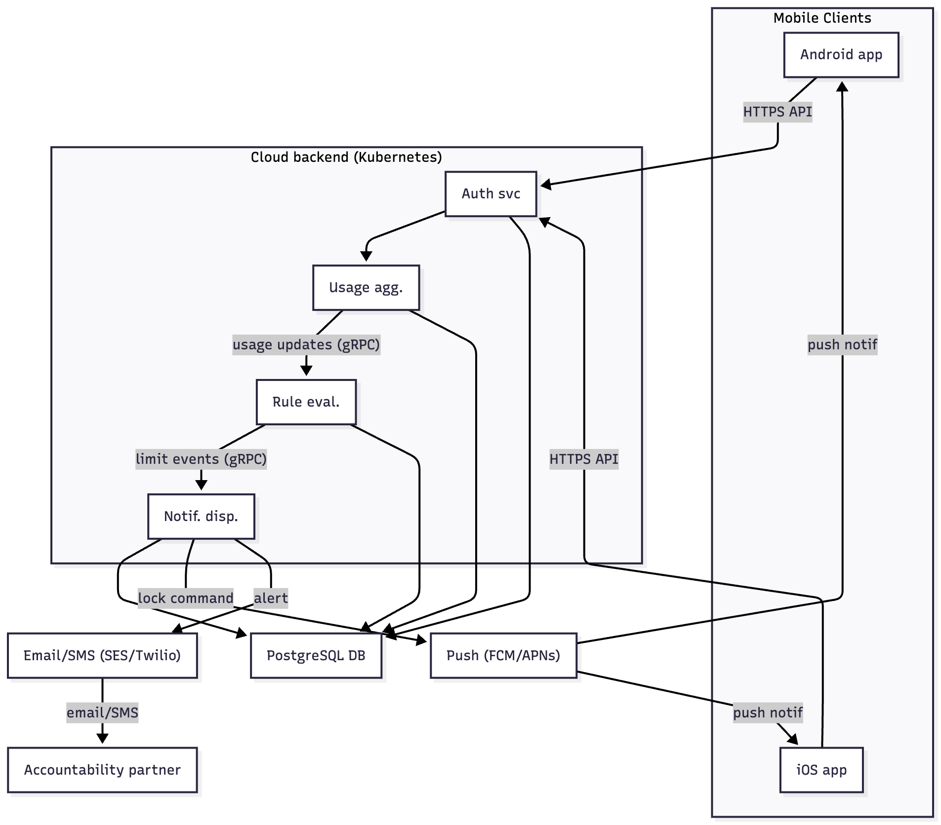
Figure 1: Deployment View of LockdIn – This diagram shows the mobile clients, backend microservices, and external integrations in the system.
In the deployment diagram above, the Android and iOS apps communicate with the backend over HTTPS. The backend consists of microservices (Auth, Usage, Rule, Notification) which share a Postgres database for persistence. Internal service-to-service calls (shown with dotted lines in the diagram) use gRPC. The Notification service connects out to external providers: it sends push messages via FCM/APNs to the mobile devices, and uses SES/Twilio to reach the accountability partner via email or SMS. This modular deployment allows independent scaling of each component and integrates with third-party cloud services for messaging .
Figure 2: Sequence Diagram of Limit Evaluation & Notification Flow – This diagram traces the steps when a user’s app usage hits a defined limit, triggering a lock and notifications:
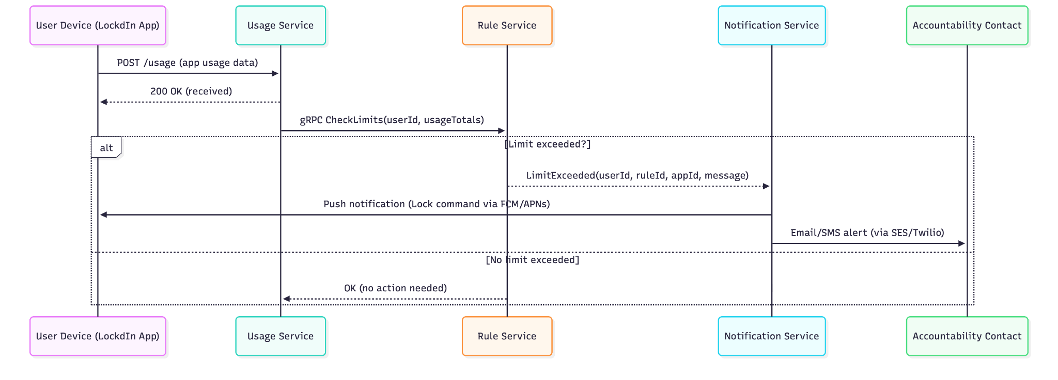
As shown in the sequence above, the LockdIn app periodically sends usage data to the backend (Usage Service). The Usage Service writes the data and then calls the Rule Service to evaluate the latest totals . If the user has not yet hit any limit, the Rule Service replies that no action is needed and the cycle continues. If a limit is reached, the Rule Service creates a limit-exceeded event and calls the Notification Service (passing the details of which rule was triggered and what to do) . The Notification Service then notifies the user’s device via a push message, which causes the app to enforce the lock immediately (e.g. disabling the target app on Android, or showing a “times up” alert on iOS) . In parallel, it sends an accountability alert to the user’s contact via email or SMS . This sequence ensures that as soon as a user exceeds their self-imposed limit, two things happen: the user is stopped from further using the distracting app, and their chosen partner is informed – reinforcing the accountability aspect. All communications occur over secure channels and the entire flow typically completes within seconds of the usage being reported, providing timely intervention. The design thus meets the functional goals of strict enforcement and notifications in a reliable, cohesive manner.

4. UML Diagrams
To complement the design description, this section provides UML diagrams of the system structure and interactions. We include a class diagram representing the core data model, and have already shown an activity workflow in Figure 3. These diagrams use standard UML notation and are labeled for clarity.
Class Diagram – Data Model: The figure below shows the primary data entities (as classes) in the LockdIn system and their relationships:
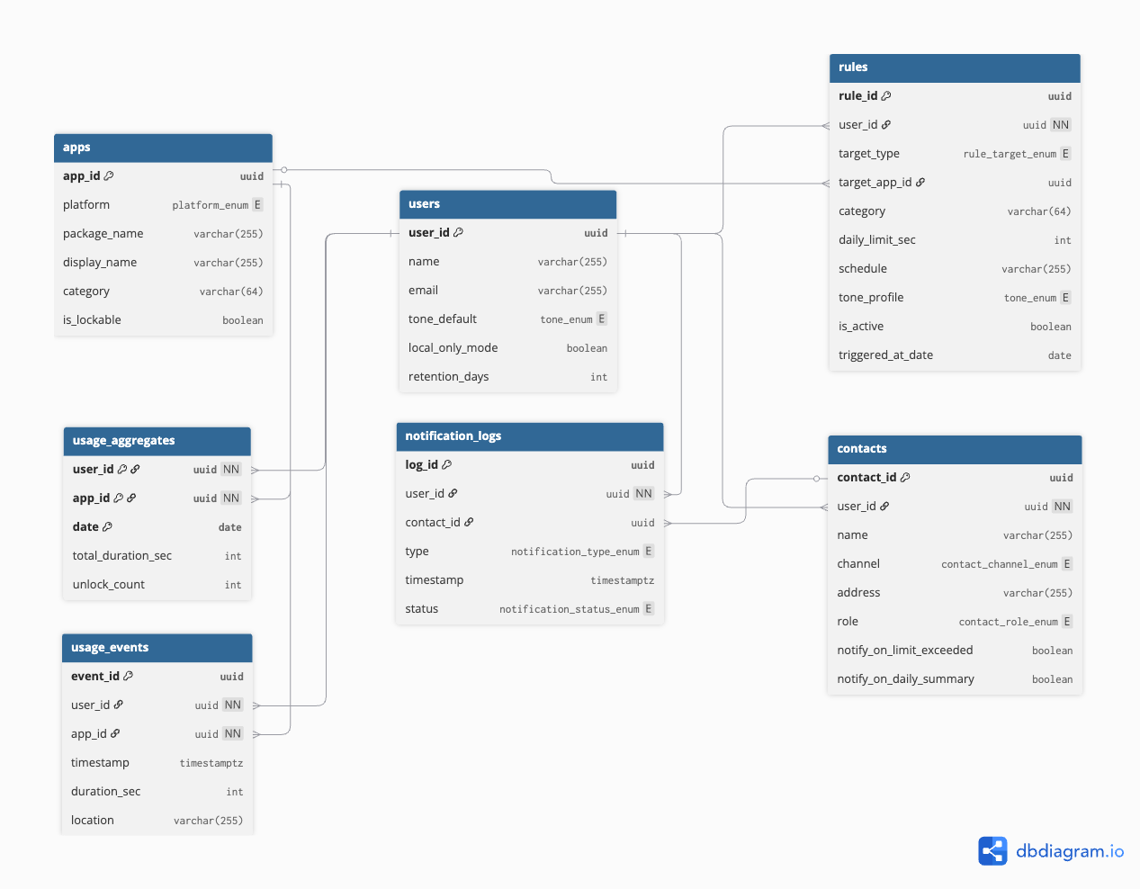
Figure 4: Simplified class diagram for key data models in LockdIn. Each class lists important attributes. The relationships illustrate that a User can have multiple UsageEvents, multiple Rules, and multiple Contacts. (For brevity, some attributes and entities are omitted.)
The detail SQL scripts are shown below:
//// Enums
Enum tone_enum {
CALM
FUN
PROFESSIONAL
}
Enum platform_enum {
ANDROID
IOS
}
Enum rule_target_enum {
APP
CATEGORY
}
Enum contact_channel_enum {
EMAIL
SMS
}
Enum contact_role_enum {
ACCOUNTABILITY_PARTNER
FRIEND
}
Enum notification_type_enum {
LIMIT_ALERT
SUMMARY
}
Enum notification_status_enum {
SENT
FAILED
BOUNCED
}
//// Tables
Table users {
user_id uuid [pk]
name varchar(255)
email varchar(255)
tone_default tone_enum
local_only_mode boolean
retention_days int
}
Table apps {
app_id uuid [pk]
platform platform_enum
package_name varchar(255)
display_name varchar(255)
category varchar(64)
is_lockable boolean
}
Table rules {
rule_id uuid [pk]
user_id uuid [not null, ref: > users.user_id]
target_type rule_target_enum
target_app_id uuid [ref: > apps.app_id] // nullable if CATEGORY rule
category varchar(64) // used if CATEGORY rule
daily_limit_sec int
schedule varchar(255) // e.g., JSON/cron-like
tone_profile tone_enum
is_active boolean
triggered_at_date date // optional: last triggered day
}
Table usage_events {
event_id uuid [pk]
user_id uuid [not null, ref: > users.user_id]
app_id uuid [not null, ref: > apps.app_id]
timestamp timestamptz
duration_sec int
location varchar(255)
}
Table usage_aggregates {
user_id uuid [not null, ref: > users.user_id]
app_id uuid [not null, ref: > apps.app_id]
date date
total_duration_sec int
unlock_count int
Note: "PRIMARY KEY (user_id, app_id, date)"
indexes {
(user_id, app_id, date) [pk]
}
}
Table contacts {
contact_id uuid [pk]
user_id uuid [not null, ref: > users.user_id]
name varchar(255)
channel contact_channel_enum
address varchar(255) // email or phone
role contact_role_enum
notify_on_limit_exceeded boolean
notify_on_daily_summary boolean
}
Table notification_logs {
log_id uuid [pk]
user_id uuid [not null, ref: > users.user_id]
contact_id uuid [ref: > contacts.contact_id]
type notification_type_enum
timestamp timestamptz
status notification_status_enum
}

In Figure 4, we see the User class with attributes like userId (unique identifier), name, email, etc., as well as user-specific settings such as toneDefault (the default notification tone profile the user prefers), localOnlyMode (whether the user opted to keep data only on device), and retentionDays (how long their data is kept). Each User can have many UsageEvent records associated (1-to-* relationship) – each UsageEvent represents an occurrence of app usage, with fields for which app (appId), when (timestamp), and how long (duration) the usage was . A User can also define multiple Rule entries (1-to-): each Rule has details about the limit, such as target type (specific app or a category of apps), the time limit (e.g. seconds per day), an optional schedule or time window when it’s active, and the tone to use for notifications related to that rule . The Rule references the userId that owns it. Additionally, a User may have multiple Contact entries (1-to-), if they add more than one accountability partner – each Contact stores the contact’s info (e.g. name and an email address or phone number) and perhaps the preferred notification method. This data model supports the functional requirements: for example, the Rule Evaluator service will use the Rule definitions and UsageEvents (aggregated per user) to decide on locks , and the Notification Dispatcher will use the Contact info to send emails .
(Note: Many other tables/classes would exist in a full implementation – e.g., a NotificationLog for sent notifications, an AppCatalog for categorizing apps, etc. The above diagram focuses on the central concepts to avoid clutter. The relationships shown enforce that if a User account is deleted, their associated rules, usage data, and contacts would also be removed, aligning with the data export/deletion requirement of HLR-9 .)
Sequence/Interaction Diagram: (Provided earlier as an activity diagram in Figure 3.) We opted to illustrate the dynamic interactions of the most critical scenario (limit enforcement) in Figure 3 under High Level Design. That diagram effectively serves as a sequence/flow representation of interactions between the user, app, backend services, and decision logic. For completeness, one could also depict a detailed sequence diagram with lifelines for User, App, UsageService, RuleService, Contact, etc., but given the complexity, the activity diagram already conveys the order of messages and actions:
- User/App -> Usage Service (send usage data)
- Usage Service -> Rule Service (trigger check)
- Rule Service -> Notification Service (limit exceeded -> send notifications)
- Notification Service -> App (push lock command) and -> Contact (email/SMS report).
The interactions follow the logical flow described in the use cases and ensure that all components work in concert to achieve the system behavior.

5. Alternate Designs
During the design process, we considered several alternative architectures and approaches, weighing their pros and cons:
Monolithic Backend vs. Microservices:
One option was to implement the server as a single monolithic application (all functionality in one codebase and process) instead of the chosen microservices architecture. The monolithic design would have been simpler to develop initially (no network calls between services, easier to deploy as one unit) and might suffice for a small user base. However, it was deemed less flexible and scalable for this project. By contrast, the microservice approach (which we chose) enables independent scaling – for example, if usage data ingestion (analytics) is heavy, we can scale the Usage Aggregator service separately . It also enforces modularity: each service has a clear focus (auth, usage, rules, notification), which improves maintainability (teams can work on different services without stepping on each other). The trade-off is added complexity in deployment and communication – we had to set up inter-service gRPC and manage multiple deployables . We judged that the benefits for reliability and future growth outweighed the costs. In a long-term perspective, microservices allow the system to evolve (e.g., replace the rule engine with a more advanced one or move notification handling to serverless) without rewriting the entire system.
On-Device Processing vs. Cloud Processing:
Another design decision was where to perform the rule evaluation and data analysis – on the user’s device or in the cloud. An alternative design could have been an on-device only solution: the app itself monitors usage and enforces limits entirely locally (perhaps using only built-in OS features), and the cloud would be used minimally or not at all. This on-device approach has privacy advantages (user data never leaves the phone) and would even work offline. However, it has significant limitations: it would be difficult to reliably prevent tampering (a savvy user could potentially disable the app), heavy data analysis might drain phone battery, and crucially it would limit features like accountability (since sending a notification to a partner requires internet/cloud) and multi-device sync. The chosen design thus offloads heavy processing to the server side – the cloud backend aggregates data and makes decisions. This allows use of more powerful computation (for analytics insights) and secure logic (rules are enforced by an authority the user can’t easily bypass). That said, we did incorporate some on-device elements for responsiveness and privacy: for example, the app does local aggregation to reduce how often it sends data, and if the backend is unreachable, the app can enforce a “local fallback” lock based on last known rules . Overall, the hybrid approach (client for data collection and UI, server for brains) gave the best balance.
Utilizing Platform-Specific Capabilities vs. Custom Implementation
We also considered leveraging more of the built-in OS features for screen time management. For instance, Apple’s Screen Time framework could handle much of the monitoring and enforcement on iOS (with Family controls, etc.), and Android has a “Digital Wellbeing” API. We could have opted to simply act as a front-end to those features. The team decided against this because it would limit customizability and the “strictness” we wanted. Instead, we implement our own monitoring and locking mechanisms (especially on Android using Device Admin APIs for true lockdown) . The alternative – relying on OS Screen Time – would have made development easier (less to implement ourselves) but at the cost of not meeting some requirements (e.g., Android’s Digital Wellbeing cannot truly lock apps, just warn; iOS Screen Time is not configurable by third-party apps to notify external contacts). Our custom approach grants us more control: for example, our app can apply humorous notifications or send data to a friend, which the OS alone would never do. The downside is increased complexity and the need to ensure we don’t violate platform guidelines (we must carefully use the Device Admin API to avoid creating a poor user experience or security issues). We chose the custom path to fulfill the project’s unique value proposition of “serious” enforcement and social accountability, features which platform default tools lack.
In summary, we chose a cloud-centric, microservices architecture with custom on-device enforcement logic because it best satisfied the project goals of strict enforcement, rich analytics, and extensibility. The monolithic or on-device alternatives were either too limited in function or would struggle to meet non-functional needs (scalability, data-driven insights, cross-user learning).
Our chosen architecture may be more complex, but it aligns with the requirement for a robust, non-bypassable solution that can evolve. For example, if in the future we want to add AI-driven habit coaching, having a modular backend makes it easier to plug in such a module (as another service) without disturbing the rest . Likewise, a microservices cloud design allows us to integrate with external services (for notifications, etc.) in a controlled manner. We conclude that the chosen design, while not the simplest, is justified given the ambitious goals and the need for a dependable, scalable system.

6. Low Level Design
We now zoom into some critical modules of the system to detail their inner workings. We will describe the responsibilities, logic, and data handling of the following key components: Usage Aggregator, Rule Evaluator, Notification Dispatcher, and Authentication module. Additionally, we outline the database schema and how data flows through these modules. Pseudo-code and error handling considerations are included to clarify the low-level behavior.

Module 1: Usage Aggregator Service (Usage Tracking & Analytics Engine)
Responsibilities: This backend module handles all incoming usage data and produces aggregated usage statistics. It implements FR-2 (App Usage Monitoring) and parts of FR-6 (Analytics Dashboard support) . Its main functions are to record raw usage events, update summary tables, and respond to queries for analytics.
Inputs: Batched usage events from the mobile app (POST /api/v1/usage). Each event includes fields such as userId, appId (application package name), timestamp, and duration (seconds) . Optionally, it may include context like location or category of the app if the client provides them. Another input is requests for analytics data (GET /api/v1/analytics?userId=...).
Processing & Internal Logic: Upon receiving a batch of events, the service iterates through each event:
for each usageEvent in incomingBatch:
validate(usageEvent) // Check required fields, auth token, etc.
insert usageEvent into UsageEvents table
update or insert aggregate record for (user, app, day):
current_total = current_total + usageEvent.duration
Validation includes verifying the userId is valid and the app identifier is in an acceptable format. After writing to the UsageEvents table, the service maintains an AggregateUsage table (or computes on the fly). For example, it might have a table keyed by (userId, date, appId) storing the total usage seconds for that day . If an entry exists, it increments the duration; if not, it creates a new entry. Additionally, there could be a WeeklySummary table or the service can compute weekly totals by summing the daily records on query. The service also triggers any needed post-processing – notably, it will call the Rule Evaluator to check the updated usage (this can be done synchronously or by emitting an event). In real implementation, this might be a message or gRPC call: “User X used App Y for Z seconds, new total today = T”. This prepares the ground for enforcement.
When an analytics query comes in, the service will fetch aggregated stats from the DB (e.g. sum of last 7 days, top 3 apps by time, etc.) and format a JSON response . Some metrics like “peakHours” or “location patterns” might be precomputed by a background job (see FR-10) and stored, or computed on the fly by analyzing the user’s usage distribution.
Data Storage: This module primarily uses two tables:
- UsageEvents(userId, appId, timestamp, duration, location) – raw log of events.
- UsageAggregate(userId, appId, date, totalDuration, category) – one row per user-app per day (or per week) to allow quick retrieval of totals. This is updated incrementally.
It may also use a CategoryAggregate or similar for category-level totals if needed. These structures enable the app’s dashboard (the service can quickly get “today’s total” or “this week’s top apps” without scanning all raw events).
Outputs:
- For event ingestion: usually a simple acknowledgment (HTTP 200) or an error code if something was wrong. No complex output; the interesting result is side effects (DB updated, and possibly a trigger to Rule Evaluator).
- For analytics query: a JSON payload like:
{
"userId": "1234",
"todayTotal": 7200,
"weeklyTotal": 30000,
"topApps": [ {"appId":"com.instagram", "time": 7200}, {"appId":"com.youtube", "time": 3600}, ... ],
"peakHour": 22,
"usageByCategory": [ {"category":"Social", "time":10000}, ...]
}
This fulfils the requirement of providing daily/weekly totals, top apps, and patterns .
Error Handling: If a request is malformed or missing data, the Usage service returns a 400 Bad Request (with a message like “Invalid usage data”) . If the userId is not found (perhaps an unauthorized app instance), it could return 404. On internal server errors (DB down, etc.), it returns 500. The service is designed to be idempotent – if the app doesn’t get a success response, it will retry sending the batch later, and the service should handle duplicates (e.g., by ignoring an event that was already recorded, perhaps using a unique event ID to check). This prevents data loss or double-counting on network failures . The service also implements basic rate limiting to avoid a misbehaving client flooding the system; e.g., if a user somehow sends usage events too frequently, it might start rejecting or throttling after a threshold.

Module 2: Rule Evaluator & Lock Enforcer
Responsibilities: This module encapsulates the logic for evaluating screen time rules and initiating lock or notification actions. It corresponds to FR-3 (Android hard lock), FR-4 (iOS soft reminder), and FR-5 (rule management) on the enforcement side . In short, given a user’s current usage and their configured rules, it decides if any rule is violated and outputs what to do (e.g. lock an app, do nothing, etc.).
Inputs: It can be triggered in two ways:
- Direct check request – e.g., an API call /api/v1/checkLimits with parameters userId, appId (the app just used), and usageSecondsToday (the updated total) . This might come from the Usage service or the app.
- Periodic scan – the service might also periodically pull from the database to see if any rules are exceeded (though event-driven is more efficient). We assume event-driven for real-time responsiveness.
Additionally, on start-up or when rules change, it loads the set of rules per user from the DB. Each rule includes its thresholds and any conditions (time window, etc.) .
Processing & Logic: For a given user usage update, the Rule Evaluator will:
rules = DB.queryRules(userId);
for each rule in rules:
if rule.target matches the app/category of this usage event:
currentUsage = getCurrentUsage(userId, rule.target) // from cache or DB
if currentUsage > rule.dailyLimit (consider time window etc.):
violation = true;
prepare action = (rule.platform == Android ? "LOCK" : "NOTIFY");
targetApps = rule.targetApps;
message = formatMessage(rule, userId);
end if
end for
If a violation is found for any rule, the service decides the action. For Android, the action is LOCK – meaning the client should lock the specified app(s). For iOS, since it cannot actually lock, the analogous action might be NOTIFY (to show an alert). In both cases, the service might include a message like “Time’s up for today on Instagram!” which can be shown to the user . The service could also include a code for how to unlock if allowed (some designs might allow an override via PIN or a cooldown period as mentioned in FR-3 acceptance criteria) , but our basic design assumes no override (or it’s handled via app UI later).
If no rule is violated (violation = false for all rules), the service outputs an “OK” or no-action result.
The Rule Evaluator must also handle rule updates: when a user adds or edits a rule, it ensures the new rule is loaded (possibly subscribing to a config update event or simply querying fresh each time). For performance, it might cache rules in memory keyed by user, updating the cache on changes.
Outputs: The primary output is an Action response. If invoked via API, it returns a JSON like:
- {"action": "lock", "apps": ["com.instagram"], "message": "Time's up! Limit reached."} for an Android lock action .
- {"action": "notify", "message": "Limit reached for Instagram – take a break."} for iOS or cases where only a notification is needed.
- {"action": "ok"} if no limits are exceeded .
This output is consumed by the Notification/Dispatch module or by the mobile app.
Additionally, if a lock action occurs, the Rule Evaluator could create a Log entry in a LockEvents table (storing user, app, timestamp, ruleID that was triggered) for auditing.
Integration with Notification Dispatcher: In our architecture, rather than directly contacting the mobile device, the Rule Evaluator will likely call the Notification Dispatcher and pass along the action (since we centralized outgoing communications in the dispatcher). For example, it might make an internal call: NotifyService.handleLimitEvent(userId, action, message, contactFlag) – where contactFlag indicates whether the user has an accountability contact to notify. The Notification service then takes over formatting and delivering (see next module).
Error Handling: If the Rule service cannot access the rules database (e.g., DB outage), it should fail gracefully. In an API context, it might return a special response like {"action":"error", "message":"Could not evaluate at this time"} . The mobile app, on receiving this, might choose to enforce a precautionary lock locally or retry after some time. If the input data is missing or malformed (though if coming from our own Usage module, that’s unlikely), it could return 400. The service must be robust to race conditions – e.g., if two usage events come in quick succession, it should handle that the usage total might have already triggered a rule from the first event. This could involve locking at the first trigger and ignoring subsequent triggers for the same rule until the next day, etc. Rule state management is important: once a rule is triggered for the day, the system might mark it as already enforced to avoid sending multiple notifications. Such state (like “rule X already locked today at 8pm”) can be stored in memory or a cache with expiry at midnight.

Module 3: Notification & Accountability Dispatcher
Responsibilities: This module is responsible for all user-facing and external notifications. It implements FR-7 (notification tone profiles) and FR-8 (accountability messages) . It acts as a centralized hub that takes triggers (like “limit reached” or scheduled summary times) and sends out appropriate messages via the correct channels.
Inputs:
- Trigger events from other services: primarily from the Rule Evaluator when a limit is exceeded (including info on which rule, what happened) , and from the Scheduled jobs (FR-10) for daily/weekly summary notifications.
- It also reads from the database the user’s preferences: which notification tone they selected, and whether an accountability contact is set (and that contact’s info) .
For example, an input might be an internal object or message: LimitEvent{userId:1234, ruleId:56, app:"Instagram", type:"dailyLimitExceeded"}.
Processing & Logic: When a trigger comes in:
- The dispatcher looks up the user’s notification settings (tone profile, contact info). Tone profile can be “Fun”, “Professional”, etc., which correspond to different template texts for messages. Let’s say the user chose “edgy” tone.
- It formats the user notification message. Using the tone profile, it might choose a phrase: e.g., for edgy tone: “That’s enough Instagram. Get back to reality 😜.” vs. a professional tone might say “You have exceeded your Instagram limit for today.” The content is generated dynamically based on the rule/app context (we plug in the app name, limit, time, etc.). This addresses HLR-4 by making notifications feel personalized .
- If the event is a limit exceeded and the user has an accountability partner, the dispatcher also generates the accountability report. This is typically a more formal summary: e.g., “John spent 2h on Instagram today, exceeding the 1h limit.” It ensures to include only agreed-upon data (no sensitive specifics beyond the fact of limit exceeded) .
- The module then sends out the notifications:
  - For the user notification: it uses platform push messaging. On Android, it might call Firebase Cloud Messaging (FCM) API to send a data notification to the app containing the message (and possibly an “unlock” action if we allow the user to unlock via app after acknowledging). On iOS, it uses APNs similarly. If the app is in foreground, alternatively the message could be delivered via a persistent connection or immediate response – but using the standard push infrastructure is simpler and reliable even if app is background.
  - For the contact notification: it uses an email/SMS API. For email, it could use AWS SES or any SMTP service; for SMS, maybe Twilio. It constructs the email with a subject like “LockdIn Alert: Screen Time Limit Exceeded” and body with the report. Then it calls the provider’s API (e.g., an HTTPS POST to send email).
- It logs the result. The Notification service will update a NotificationLog table with entries like (userId, type=“limitExceeded”, contactNotified=true, timestamp, status=sent). This helps in auditing and in implementing any resend logic. For instance, if an email bounces, the log might mark status “bounced”, and the system could disable that contact or inform the user.
If multiple events come closely (say user exceeded two different app limits around the same time), the service may coalesce them or apply a rate limit to notifications (to avoid spamming the user or contact) . Typically, one violation triggers one set of notifications, and then it won’t notify again for the same rule within, say, an hour.
For scheduled summaries (e.g., “Your daily screen report” each night at 9pm), the dispatcher would similarly gather data (maybe provided by Usage service or precomputed) and send a notification or email summary (if user opted in for email reports).
Outputs: The direct outputs are the sent notifications themselves (not something that the system returns as an API result – rather, the effect is external). However, the module might return a status to internal callers. For example, after sending, it could respond to the Rule Evaluator with “notification_sent” or just an acknowledgement. More importantly, the outcomes are recorded in logs as described.
Error Handling: If the push notification fails (e.g., FCM service down or returns an error), the dispatcher can retry a few times. If a user’s device is unreachable (perhaps uninstalled app), FCM might return a specific error and we might mark the user’s device token as invalid. For emails/SMS, if the third-party API call fails due to a network issue, we queue a retry. If it fails due to bad address (bounce), we mark that contact and perhaps stop further attempts until the user updates it. The dispatcher should not crash on exceptions – each send operation is wrapped in try-catch, and failures are logged but do not halt the processing of other messages. In worst case, if dispatcher is down, the system can temporarily function without sending notifications (user might not get immediate feedback, but core locking could still happen on Android since the Rule Evaluator’s command might reach the device via a direct channel or next app sync). We also implement a throttle: if a buggy loop tried to send hundreds of messages, we detect unusual volume and break out to prevent spam. This ensures compliance with any messaging limits and prevents runaway notification storms.

Module 4: Authentication & User Management
Responsibilities: This module covers user sign-up, login, logout, and account management (password reset, etc.). It isn’t explicitly a highlighted requirement except the need for secure authentication (part of FR-1) , but it is critical infrastructure for the app. It ensures only authorized users (or device-only sessions) can send data and get data.
Inputs:
- Registration requests: e.g., POST /api/v1/register with user-provided email, password (or OAuth token if using Google sign-in).
- Login requests: POST /api/v1/login with credentials.
- Token verification on each API call: The Auth module (or an API gateway) intercepts other service calls to verify the user’s session token or API key.
Processing:
- For registration: Validate the email format and password strength. Create a new User entry in the database (User table with unique userId). The password is hashed with a salt (using a strong algorithm like bcrypt) . If email verification is required, generate a verification token and perhaps send a verification email (this could be done via Notification module as well). If using OAuth, verify the token with the OAuth provider and create a user linked to that identity. The result is a new account.
- For login: Verify the email/password against the stored hash. On success, create a session token (e.g., JWT or random token stored in a sessions table) and return it to the client. The token will be used in subsequent calls (e.g., as an Authorization header). The Auth service may also handle “anonymous device-only mode” by issuing a token tied to device ID without a user account.
- The Auth module also allows password reset (generate email with reset link) and logout (invalidate token).
Data Storage: In the User table, important fields include userId (UUID), email, passwordHash, createdAt. There might also be fields for preferences, which we saw in the class diagram (toneDefault, localOnlyMode, etc.) – these could be in the User table or a separate Preferences table. A Session table or cache stores active sessions if not using stateless JWTs. If GDPR compliance is needed (part of HLR-9), the user management module also handles data deletion: when a user deletes their account, it triggers deletion of their associated records (rules, events, contacts) as per FR-9 .
Outputs:
- Registration returns a success (possibly with token directly if we auto-login the user).
- Login returns an auth token and maybe user profile info.
- Auth failures return 401 Unauthorized with an error message.
- The module might also output events like “user created” that other parts (analytics or welcome emails) could use.
Error Handling: Security is paramount: on login failure (wrong password), respond with a generic error (don’t reveal whether email was valid or not). Use rate limiting or exponential backoff on repeated failed logins to prevent brute force attacks. Passwords are never stored in plaintext (only hashes) . The service should also enforce email uniqueness. If the database is down during auth, logins may fail (which essentially locks out users – so we’d want high availability for this module). We could have a fallback offline mode where the app remembers if it was recently logged in and allows some local functionality, but generally, if auth is unavailable, the app will show an error. Sessions are configured to expire after a reasonable period for security . The Auth service also ensures that if a user is in “device-only” mode, no personal data is stored server-side for them (fulfilling a privacy option).

Database Design & Schema Overview
Bringing the data pieces together, the central database (PostgreSQL) contains tables corresponding to the classes discussed and more. A possible schema (simplified) is:
- User: (userId PK, email, passwordHash, name, toneDefault, localOnlyMode, retentionDays, createdAt, etc.)
- UsageEvent: (eventId PK, userId FK->User, appId, timestamp, duration, location) – this can grow large; we may partition it by date or have the retention job purge old entries after X days.
- UsageAggregate: (userId+date+appId PK, totalDuration) – possibly also weekly or monthly aggregates, and maybe fields for category totals.
- Rule: (ruleId PK, userId FK->User, targetType [app/category], targetValue [e.g. “com.instagram” or “Social”], dailyLimitSec, weeklyLimitSec, activeSchedule [e.g. “9:00-17:00” or null], toneProfile, isActive, createdAt).
- Contact: (contactId PK, userId FK->User, name, method [email/SMS], contactInfo [email address or phone], verified(bool)) – the verified flag if we send a confirmation to the contact perhaps.
- NotificationLog: (logId PK, userId, type [limit_alert or summary], contactId, timestamp, status [sent, bounced, etc.], messageSnippet).
Additionally, we might have:
- Session/Token: (tokenId, userId, issuedAt, expiresAt) if not using stateless JWT.
- AppCategory: (appId, categoryName) – a reference table if we classify apps by category for insights.
- AuditLog: if needed for admin/DevOps to see system actions.
ER Diagram Note: The class diagram in Figure 4 already illustrated the core relationships: User–Rule (one-to-many), User–UsageEvent (one-to-many), User–Contact (one-to-many). The database schema enforces these with foreign keys. On delete cascades can be set such that if a User is deleted, all their rules, events, contacts, etc., are deleted (or anonymized) to meet the data deletion requirement . Indices are added on important queries, e.g., index on UsageEvent(userId, timestamp) to fetch a user’s recent events quickly, and on Rule(userId) since we often query a user’s rules.
Consistency: We ensure that writing a UsageEvent and updating the UsageAggregate happen in one transaction (so totals never diverge from raw data). Similarly, when a rule is inserted, it’s immediately visible to the Rule Evaluator on next check (we could send an invalidation message to refresh cache). These low-level design considerations guarantee that the system’s data remains consistent and accurate, which is vital for user trust (imagine if the dashboard said you used 1h but the rule locked you out as if you used 2h – that must not happen).
In pseudocode, a daily summary job (part of FR-10) might run at midnight:
for each user:
totals = sum durations from UsageEvent where date = yesterday (or from UsageAggregate)
store totals in DailySummary table (userId, date, total, topApp, etc.)
purge UsageEvent where date < (today - retentionDays) // to enforce data retention limit
This uses retentionDays from User settings . Summaries can be used for weekly emails or for faster dashboard queries of past days.
Through this low-level design, we ensure each module is robust: Usage Aggregator efficiently handles data input/output, Rule Evaluator ensures timely enforcement, Notification Dispatcher communicates effectively with end-users and contacts, and Auth secures the system. Each component has been considered in terms of how it fails (and recovers), so that the overall system meets the reliability and security requirements (e.g., using least-privilege access: each microservice only has DB permissions it needs, etc., as noted in architecture ). This modular breakdown also makes it easier to test components individually (for example, we can unit test the rule evaluation logic with various usage scenarios).

7. Conclusion
In conclusion, the LockdIn mobile application is structured to fulfill its mission of curbing screen addiction through a combination of strict enforcement and supportive analytics. The system design we’ve detailed – comprising a feature-rich mobile client and a scalable cloud backend – addresses the functional requirements like usage monitoring, lockdown rules, and notifications, while also satisfying non-functional needs such as privacy (minimizing data collected and honoring user consent) , security, and user experience.
By tracing high-level requirements to concrete components and data models, we’ve ensured that each requirement (HLR-1 through HLR-9) is accounted for in the architecture. The provided diagrams and flows illustrate how a user moves from onboarding, to daily usage under the system’s guidance, to receiving feedback and adapting their habits – all enabled seamlessly by the designed modules working in concert. The alternate designs considered provided insight into why the chosen architecture is appropriate: it offers a robust, extensible foundation for LockdIn’s goals, as demonstrated by our alignment with project assumptions and constraints (e.g., leveraging Android capabilities fully while working within iOS limitations) .
This design is positioned not only to meet the initial pilot metrics (like 25% screen time reduction and 70% retention) but also to evolve with future needs. For example, new features (perhaps an AI coach or integration with wearable devices) could be added as new services without major overhauls. In summary, the system design balances strict control with user empowerment, aiming to deliver a reliable tool for digital well-being. It represents a comprehensive solution that is technically sound and grounded in the requirements and expectations set out in the project charter and requirements specifications.

